OFFICE OF THE PRINCIPAL GOVERNMENT COLLEGE FOR WOMEN MAHENDERGARH, HARYANA (123029)
E-mail: gcw_mohindergarh@yahoo.com Phone No. - 01285-220547
Ref. No. …………………………. Date : ……………………….
Certificate
Metric 5.1.4.1
It is certified that Guidance and Career counseling/ Placement cell is functional in the college and an Assistant Professor is the in charge of the cell, who arrange periodic session for the guidance of the students who desires to register for the said purpose the record of students candidates is kept after taking the undertaking from the students who come to obtain the character certificates from the institute after selection for a particular job
During the period 2017-18 to2021-22 following Number of students benefitted by guidance for competitive examinations and career counseling offered by the institution year wise during last five years the said scheme. It is further submitted that the information is compiled as provide by the Teacher concerned and is true to best of knowledge.
.
Years | 2021-22 | 2020-21 | 2019-20 | 2018-19 | 2017-18
Numbers of Students benefited | 100 | 150 | 100 | 427 | 67

(NAAC In-Charge) Principal
Govt. College for Women,
Mahendergarh

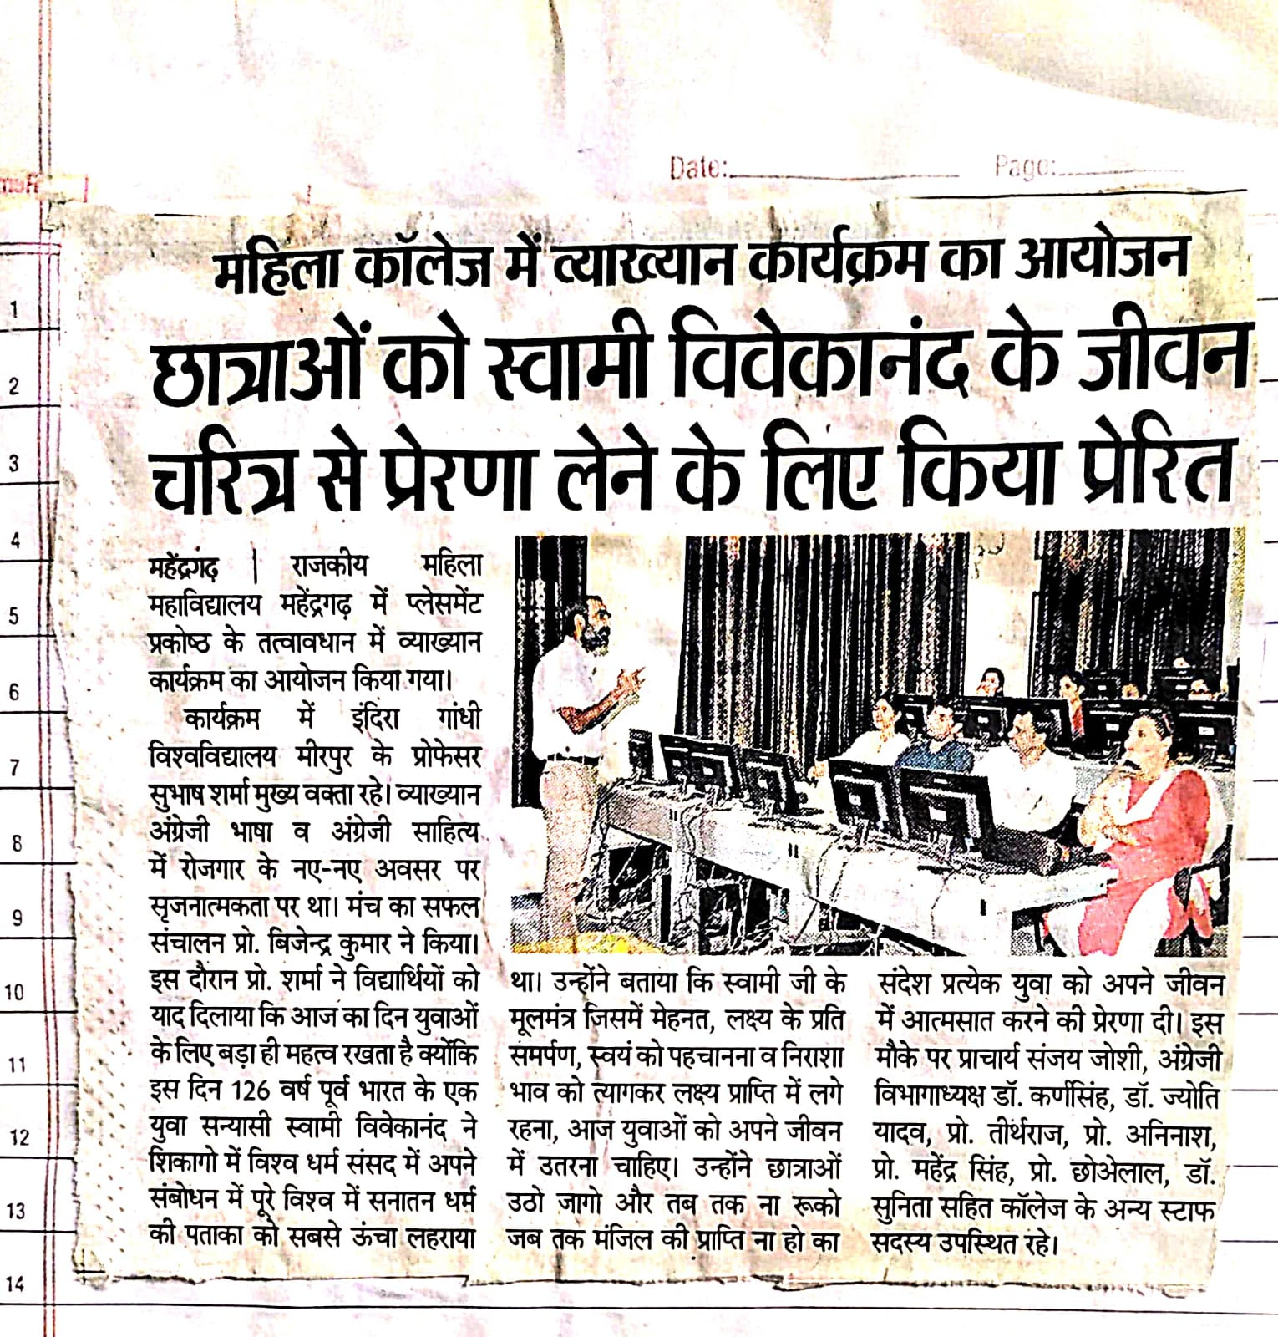

OFFICE OF THE PRINCIPAL GOVERNMENT COLLEGE FOR WOMEN MAHENDERGARH, HARYANA (123029)
E-mail: gcw_mohindergarh@yahoo.com Phone No. - 01285-220547
Ref. No. …………………………. Metric Date : ……………………….
Report From 2017 to 2022 of Placement and Career guidance cell
Session | Name of the Activity | No. of Students participated | Venue | Date | Remark
2017-18 | Pre Job fair Training | 45 | GC Mahendergarh | 19,20,21 Feb2018
 | Zonal Job Fair | 22 | GCG Sector 14, Gurugram | 5-03-2018 | One girl selected in ICICI Bank  Monu M.Com(P) Roll.No-1487420003
2018-19 | Pre Job fair Training | 29 | GC, Mahendergarh | 25 -01-2019
 | Pre Job fair Training | 48 | GC, Mahendergarh | 27 -01-2019
 | Pre Job fair Training | 48 | GC, Mahendergarh | 28 -01-2019
 | Zonal Job Fair | 22 | GCG,Sector14, Gurugram | 07-02-2019 | One Girl Selected in Reliance Digital Sobha B.ComIII Rollno-96210037
 | Extension Lecture on  Career opportunities in commercial field | 70 | GCW Mahendergarh by  Dr.Sudershan Principal GC, Bahu
 | Extension Lecture on  Career opportunities in Banking Sector | 100 | GCW Mahendergarh given by  Mr. Paramver  Asst. Manager  OBC ,Fridabad | 18-02-2019
 | Extension Lecture on  Career opportunities in private Sector | 110 | GCW Mahendergarh Given by  Mr. Pankaj Yadav  HR &IR Carrier Midea India Pvt. Ltd. | 20-02-2019
2019-20 | Extension Lecture on  'Employment opportunities in Humanities and Language' | 100 | GCW , Mahendergarh given by  Dr. Subhash Sharma  Chair Person Dept. of English , IGU ,Rewari | 11-09-2019
2020-21 | Extension Lecture on "Resume &Email Writing" | 150 | GCW,Mahendergarh given by  Dr. Avinash | 14,15Jan2021
2021-22 | Extension Lecture on 'Personality Development &Communication Skill' | 100 | GCW , Mahendergarh given by  Dr. Subhash Sharma  Chair Person Dept. of English , IGU ,Rewari | 09May2022

(NAAC In-Charge) Principal
Govt. College for Women,
Mahendergah

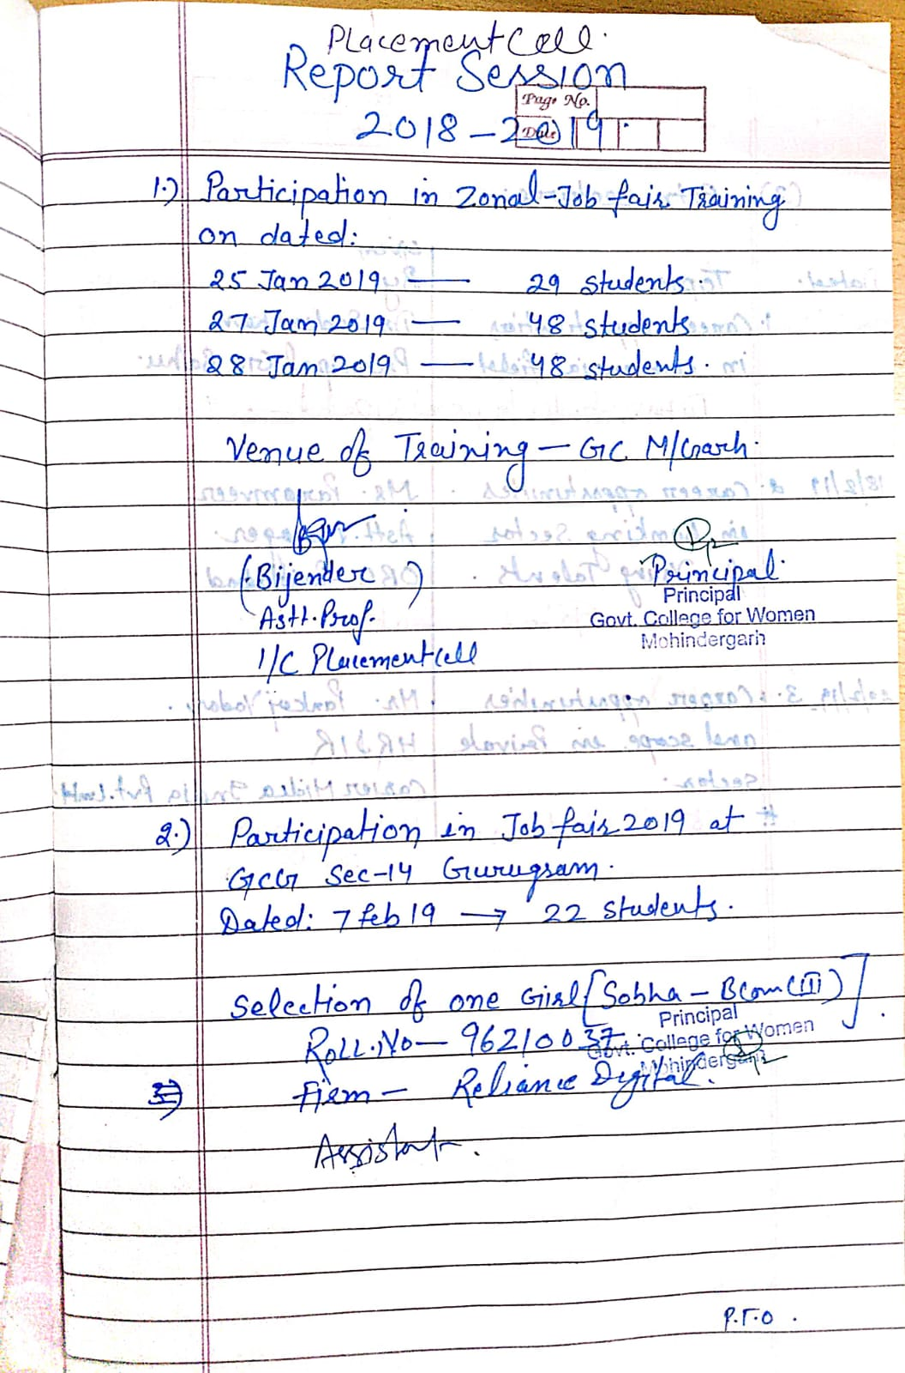
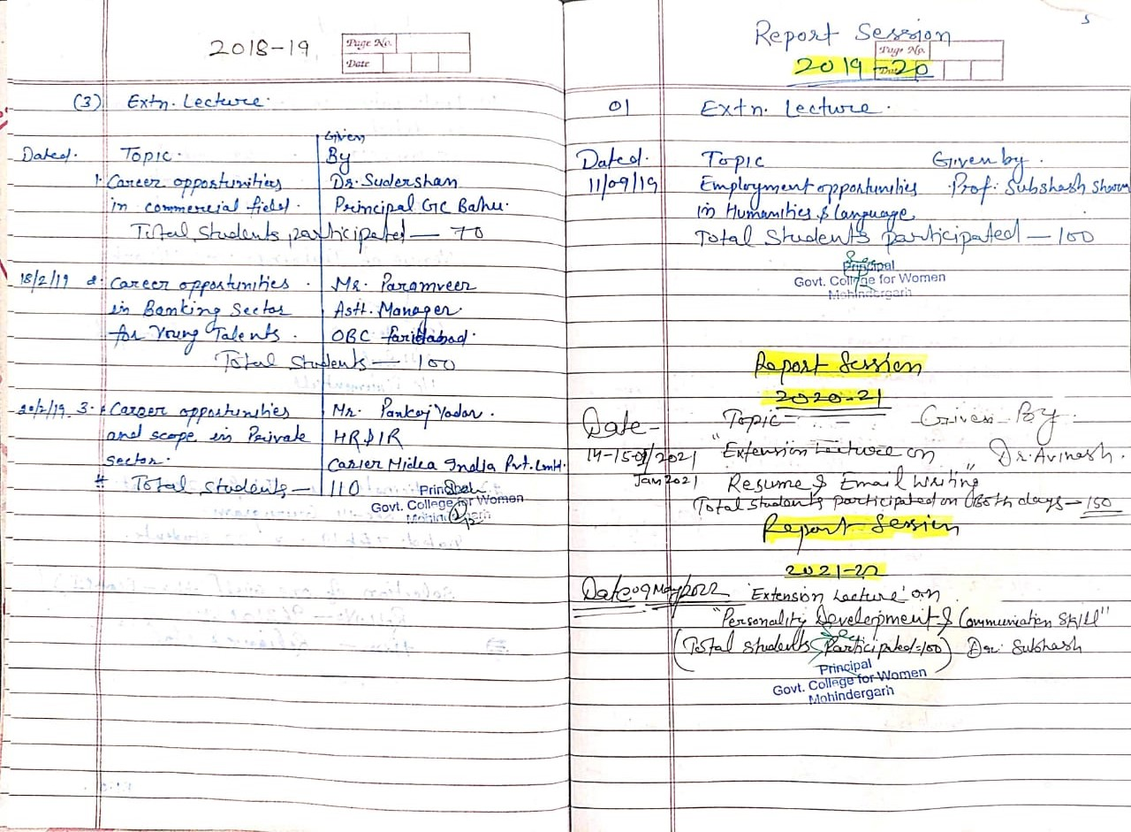

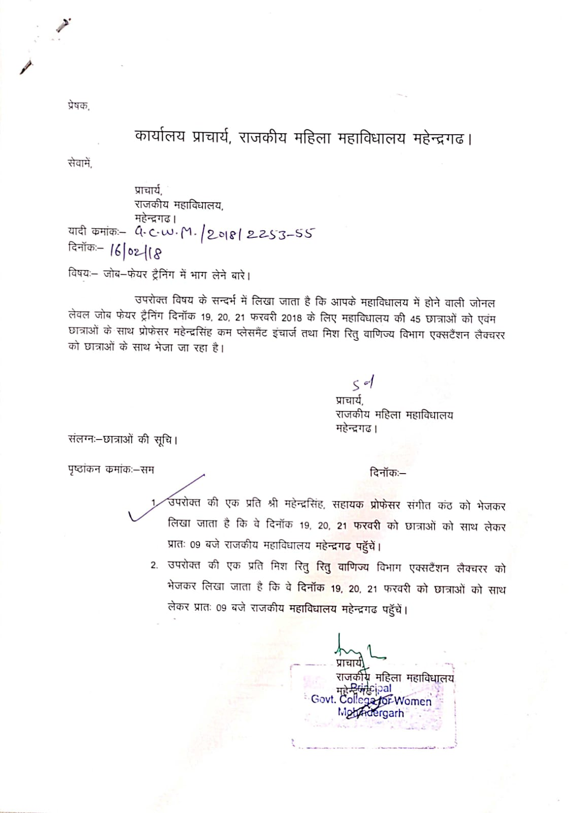
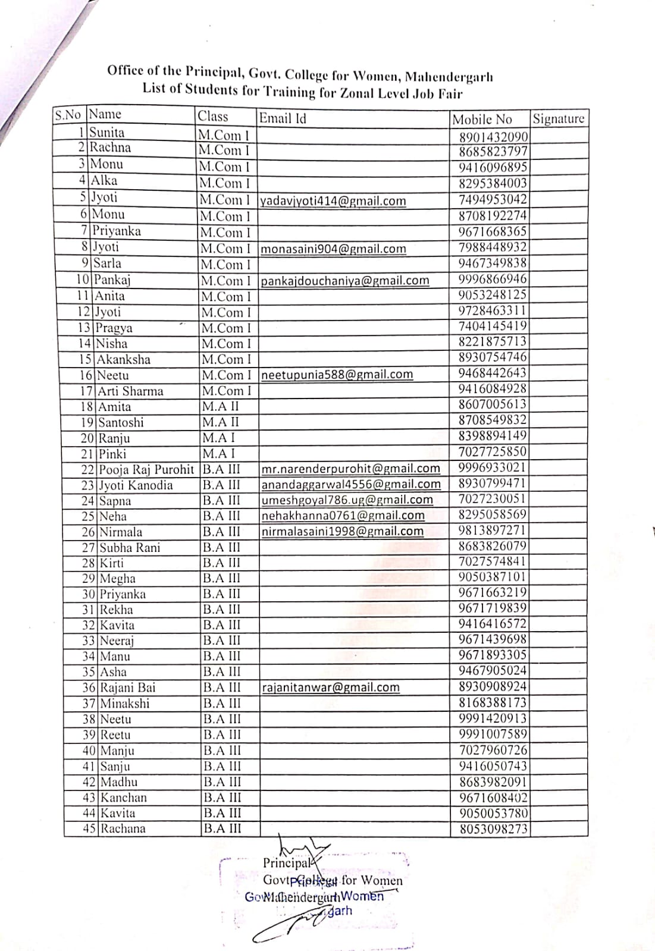
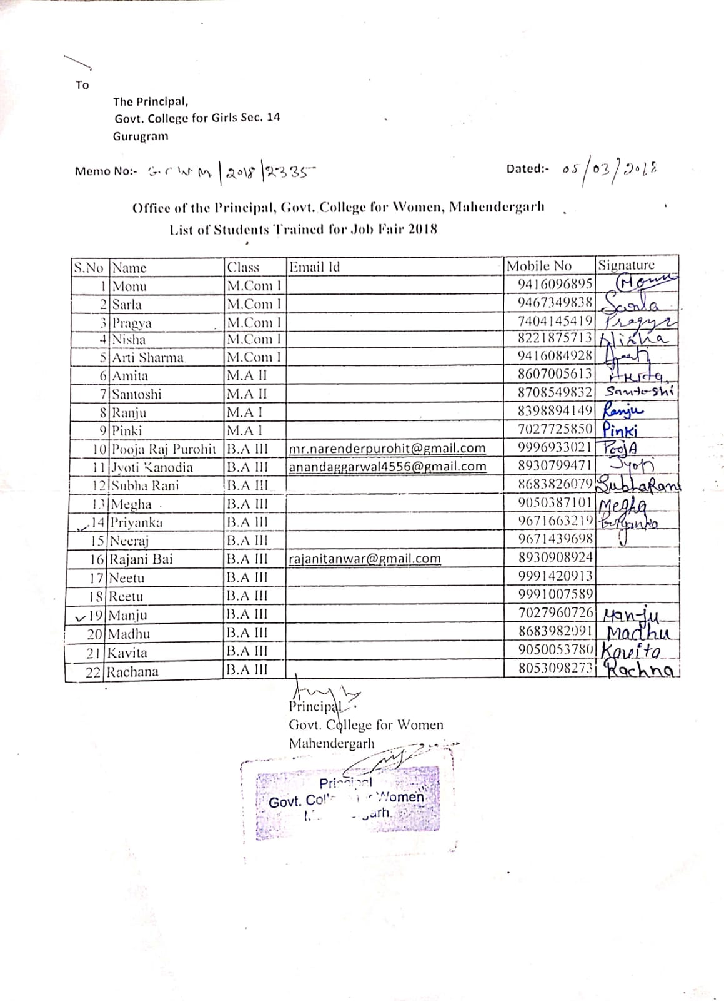
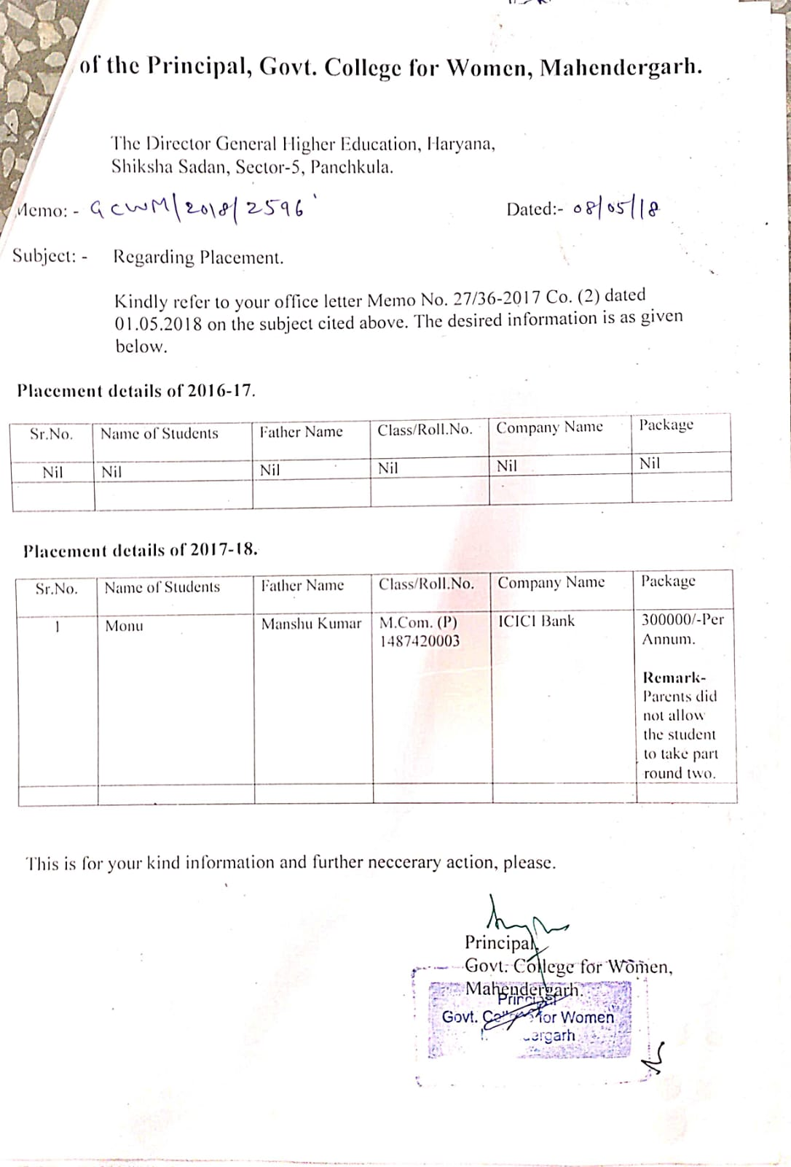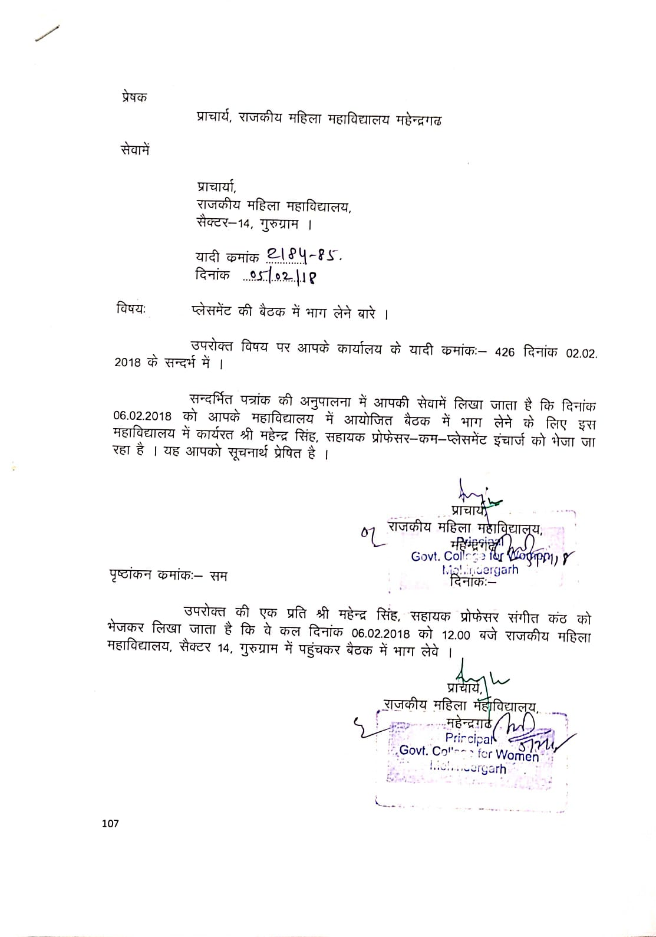
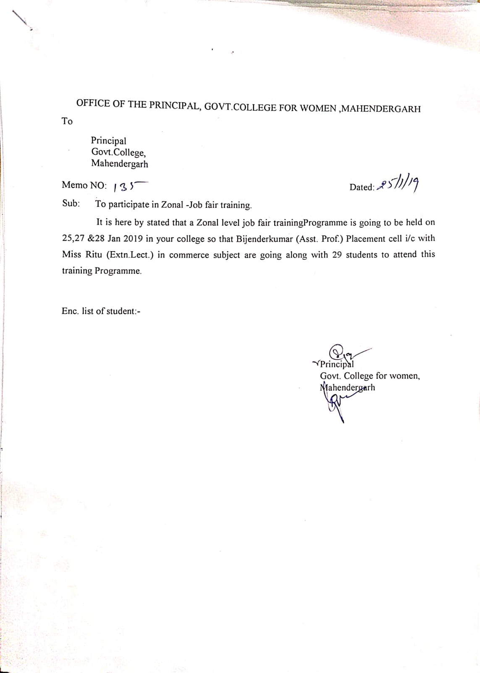
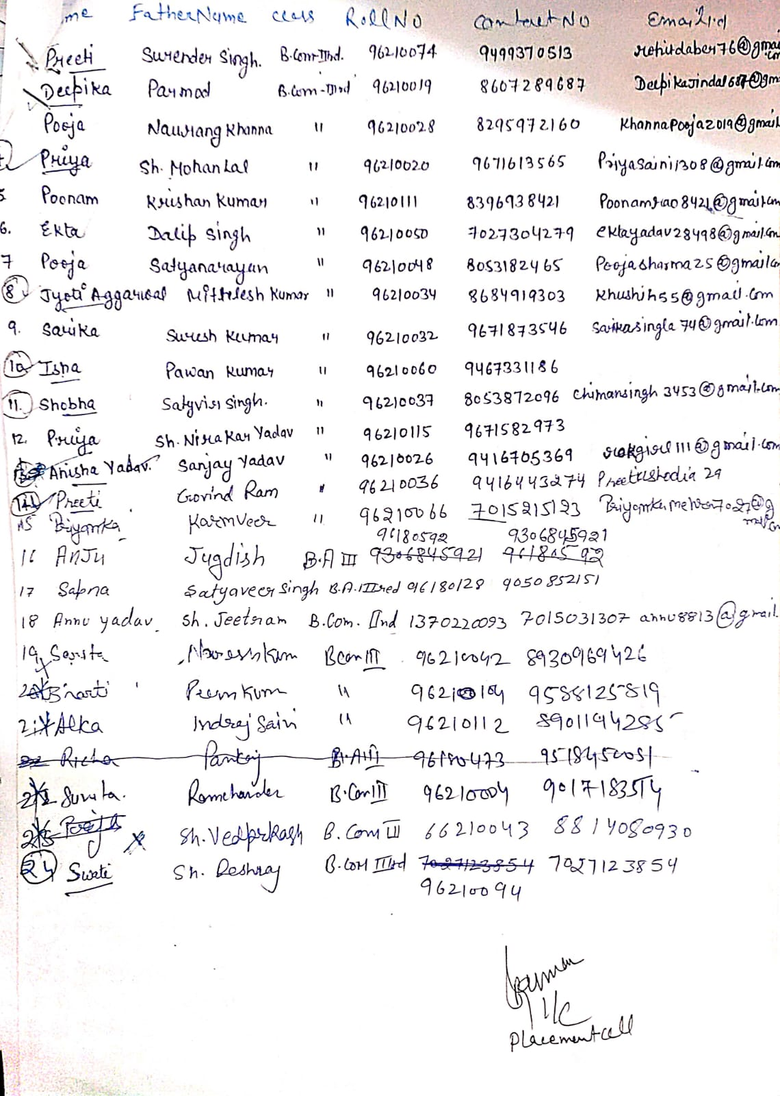
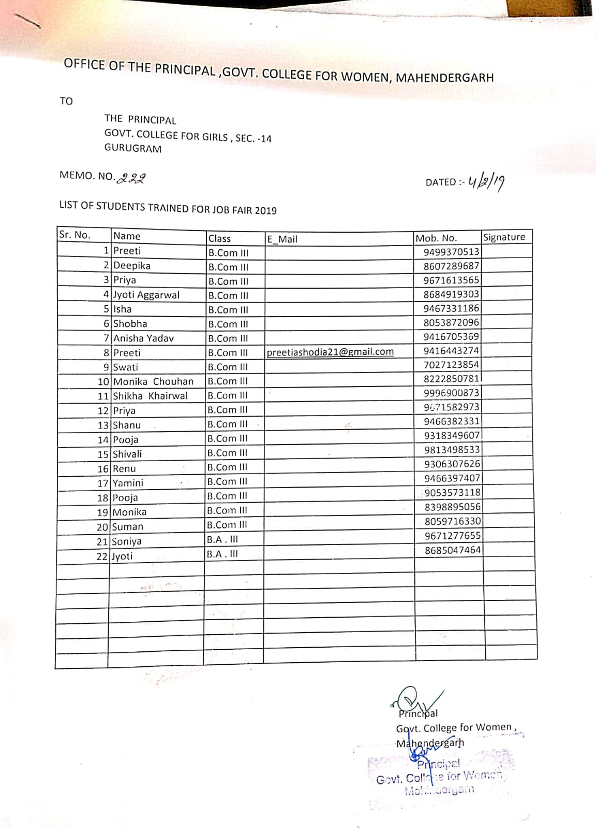

Extension lecture on 'Career opportunities and Scope in Private sector' by Mr. Pankaj Yadav HR&IR Career midea Pvt. Ltd.

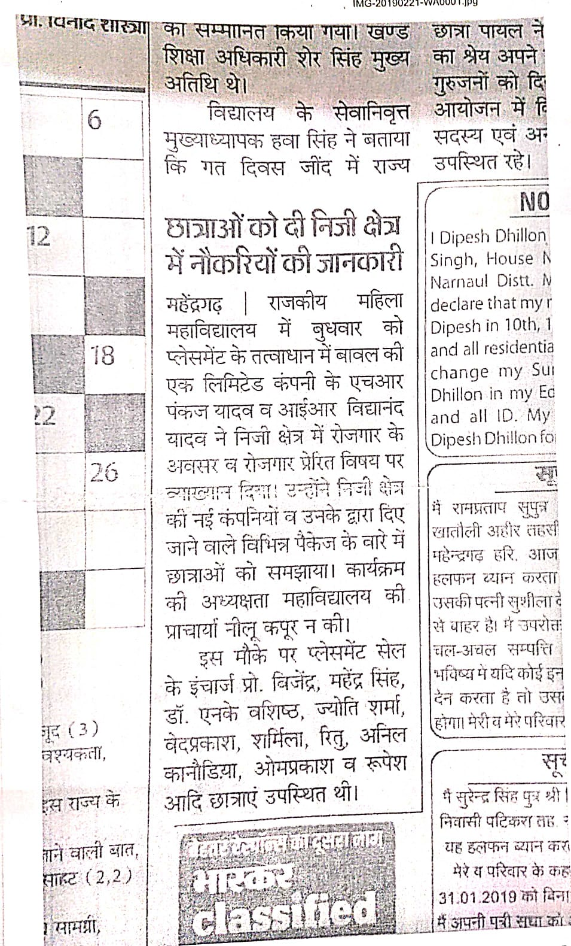

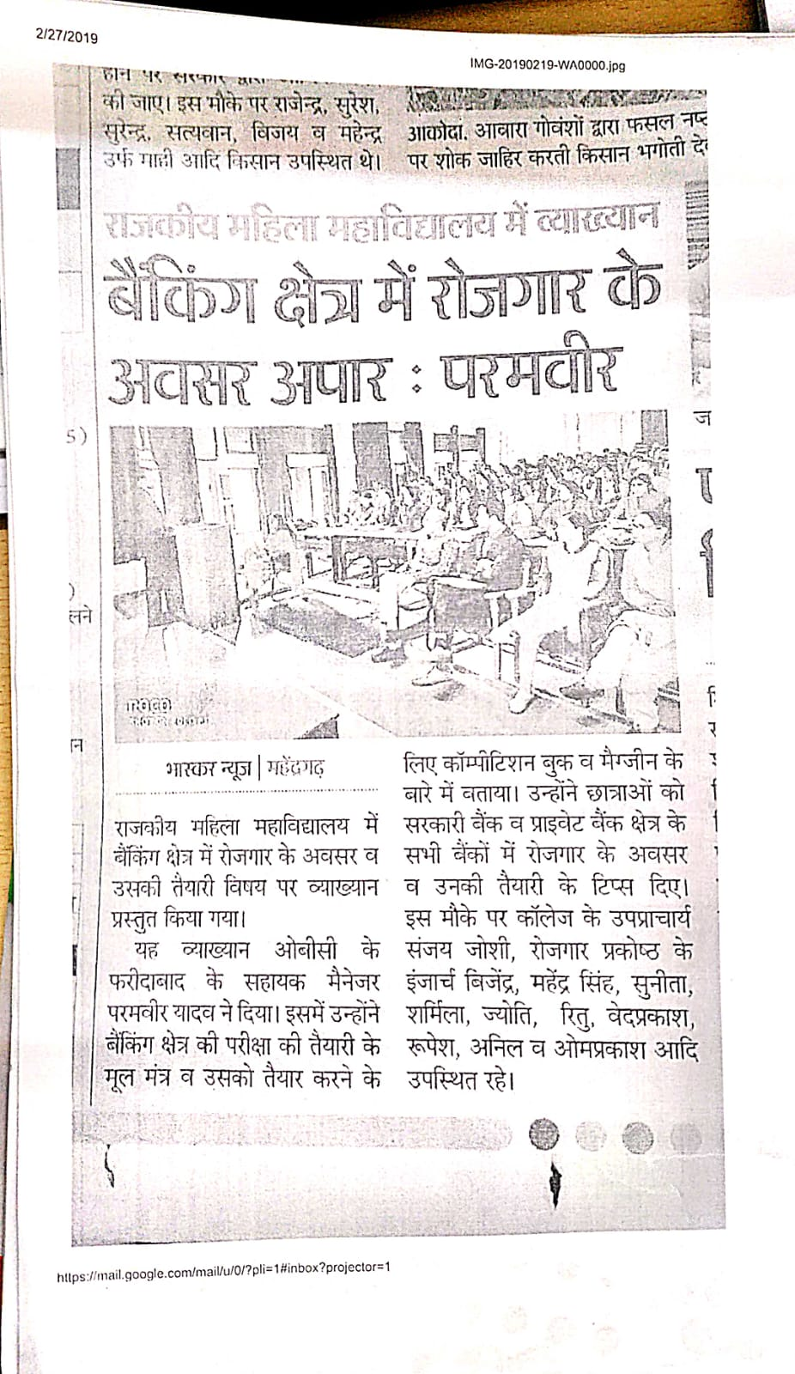
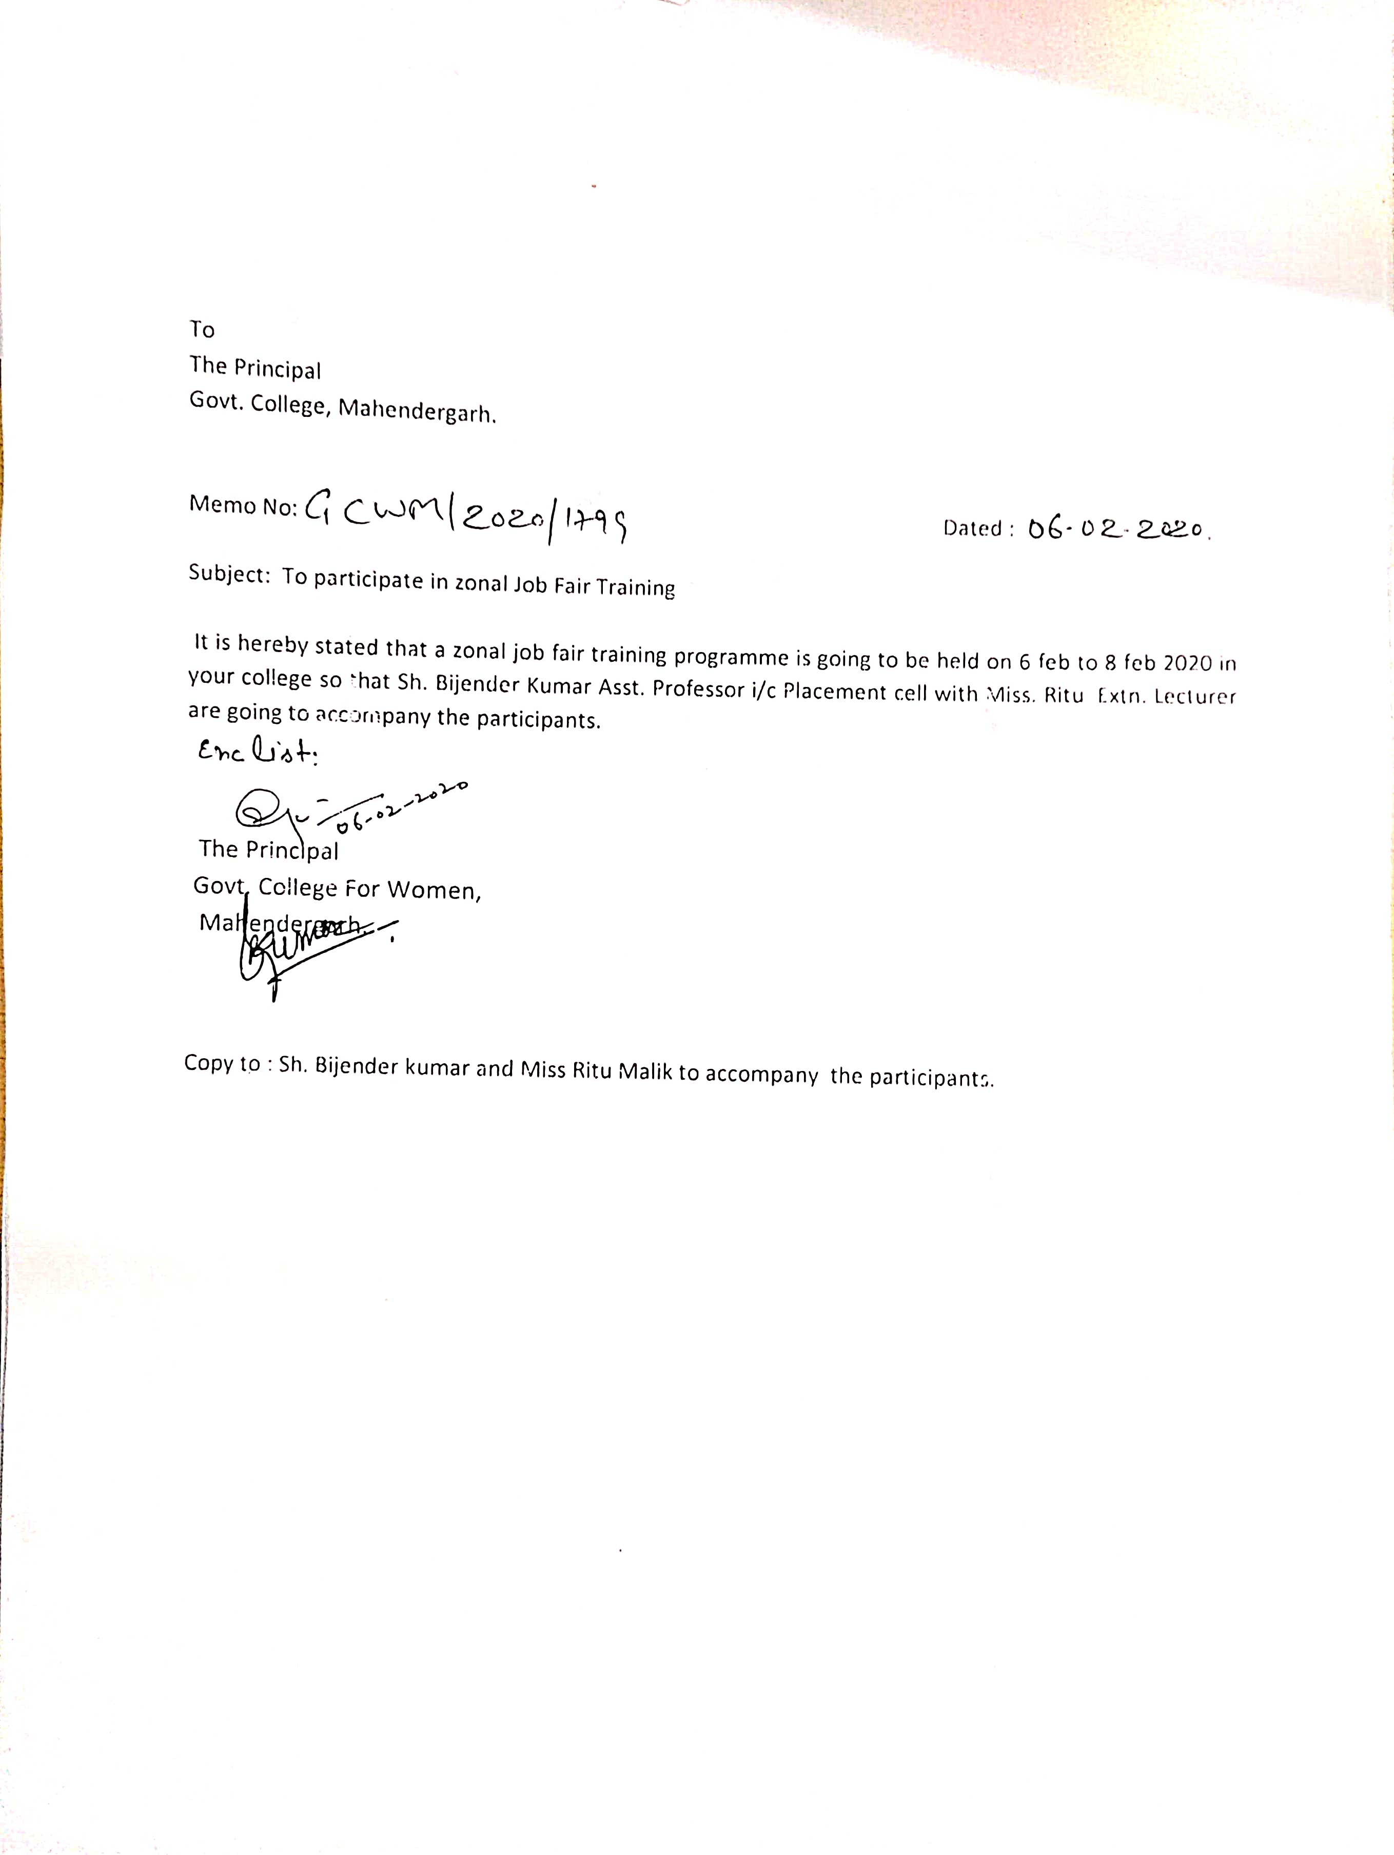

Extension lecture on 'Resume and Email writing' by Dr Avinash on14Jan2021

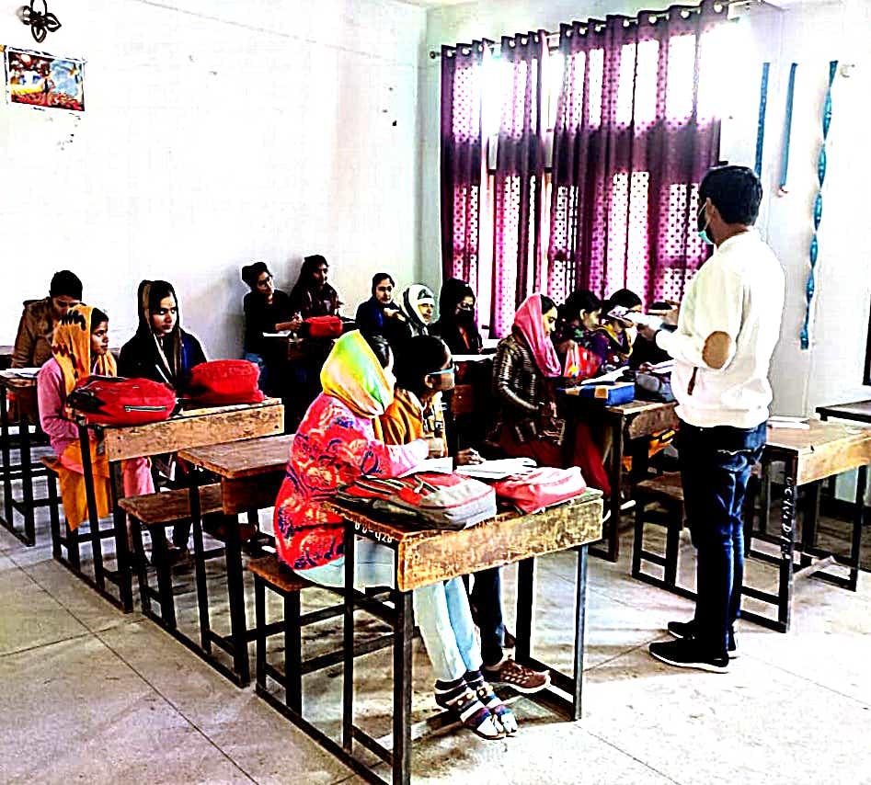

Extension lecture on 'Resume and Email writing' by Dr. Avinash on15Jan2021

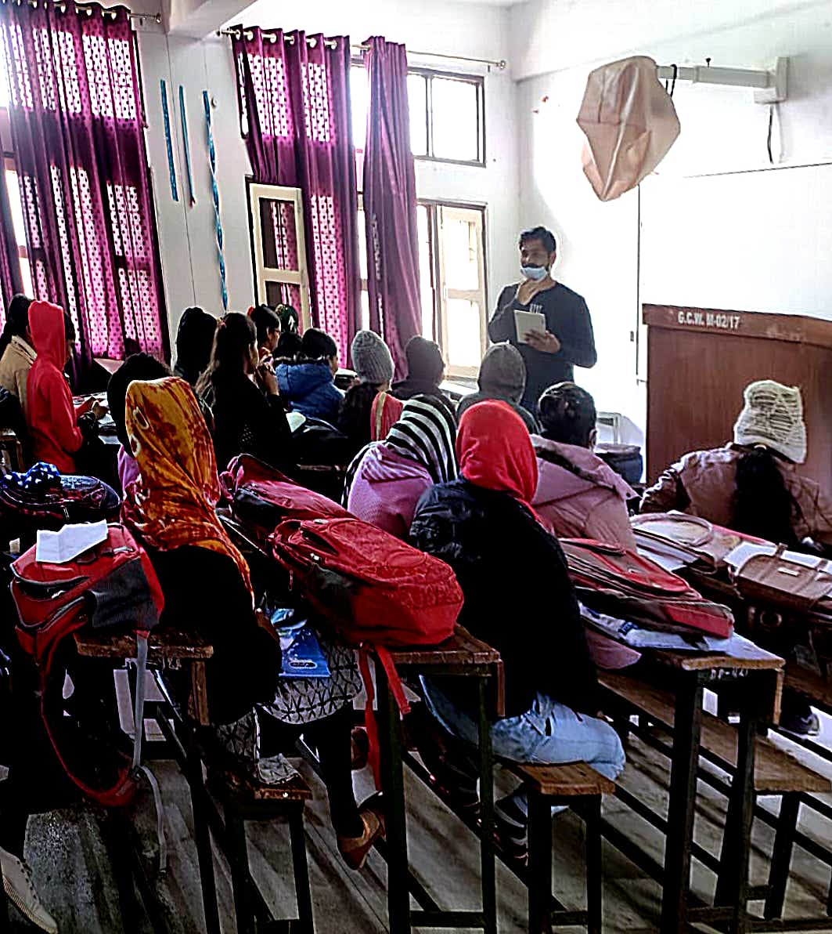

Extension lecture on 'Personality Development and Communication Skill' by
Dr.Subhah Sharma on15Jan2021

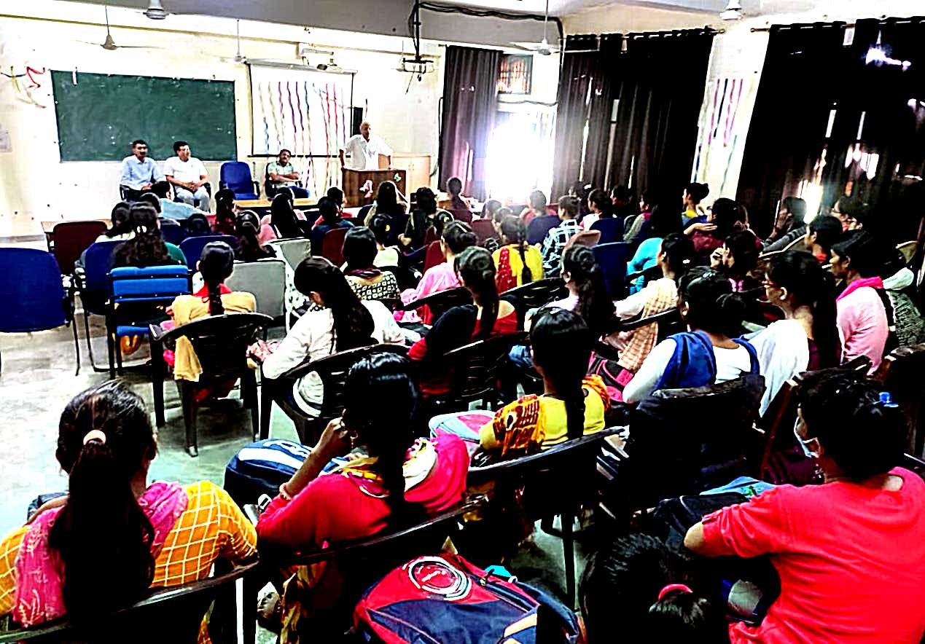

OFFICE OF THE PRINCIPAL GOVERNMENT COLLEGE FOR WOMEN MAHENDERGARH, HARYANA (123029)
E-mail: gcw_mohindergarh@yahoo.com Phone No. - 01285-220547
Ref. No. …………………………. Date : ……………………….
Metric 5.1.4
Detail of Placements (Session 2017-22)

Year |  | Registration number/roll number for the exam |  | Names of students selected/ qualified
2017-22 |  | Class |  | Name | NET | State / Center government examinations
 |  | B.A. |  | Kavita |  | DSSB
 |  | M.Com(P) |  | Monu |  | ICICI
 |  | MA English |  | Monika |  | Delhi Police
 |  | MSc Geo |  | Priyanka |  | Delhi Police
 |  | BA |  | Renu |  | Delhi Police
 |  | B.com |  | Sobha |  | Relianc Digital
 |  | B.A. |  | Manisha |  | Teacher
 |  | M.Com |  | Mamta |  | Delhi Police
 |  | BA |  | Preetam |  | Teacher (RAJ)
 |  | BA |  | Manoj |  | Group D Railway
 |  | MA English |  | Archana | Yes
 |  | BA |  | Preeti |  | Delhi Police
 |  | MSc Geo |  | Kirti | Yes
 |  | BA |  | PoojaVarma |  | Animal Husbandry
 |  | MA English |  | Manju |  | Delhi Police
 |  | MSc Geo (UP 09661967) |  | Jyoti | Yes
 |  | BA |  | Manisha |  | Delhi Police
 |  | MSc Geo |  | NishaBai |  | Raj Police
 |  | MA |  | Manisha | Yes
 |  | BA |  | Manoj |  | Supreme Court (Asstt. )
 | B.A |  | Poonam |  |  | Teacher level(3)  Rajasthan
 | BA |  | Anju |  |  | Reliance

(NAAC In-Charge) Principal
Govt. College for Women,
Mahendergarh

